Running a Wordcount MapReduce Exampleg
Grishma lamsal
2431171

If jps (Java Processing Status) lists all the above running java processes, then you are good to continue with the below commands.

- Create a directory in hadoop file system

~$ hdfs dfs -mkdir -p /user/hdoop/input
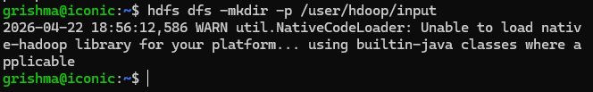
- Copy file to HDFS.

~$ hdfs dfs -put ~/hadoop-3.2.4/LICENSE.txt /user/hdoop/input/
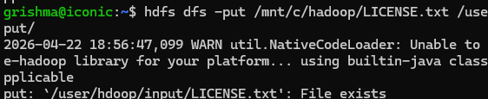
- Change directory to your hadoop installation directory using $HADOOP_HOME which is an environment variable that points to it.

~$ cd $HADOOP_HOME

- Run the wordcount mapreduce example.

~$ hadoop jar share/hadoop/mapreduce/hadoop-mapreduce-examples-3.2.4.jar wordcount /user/hdoop/input /user/hdoop/output
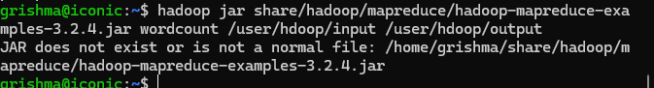
- Show results

~$ hdfs dfs -ls /user/hdoop/output

~$ hdfs dfs -cat /user/hdoop/output/part-r-00000
